Student Companion

Project Management Report

COMP-SCI 5551 Advanced Software Engineering

Group 7

Sri Harsha Chennavajjala (7)

Teja Garidepally (12)

Raj Kiran Reddy Munnangi (32)

Suhas Sai Raparthi (51)

# Introduction

This document is intended to provide an overview for the management of project named “Student Companion”. The task management is also discussed. The outcome of the project management report is how the project is divided in to tasks among group and how each task is managed.

# Project Goal and Objectives

The goal of this project is to provide various functionalities that a student uses regularly such as updating the profile, checking for computer lab availability, library study room reservation etc. The student details will already present in the database. The student has to login before he uses these functionalities. Main objectives of this application are:

* To reduce the student’s stress and to save the student’s time by providing the latest availability of the computer labs.
* To develop an application that helps the students in taking the decision on to which laboratory the students have to go.
* To secure the information by providing a login form to the end user.
* To provide a tool with which the students will be able to reserve the library study rooms.
* To ensure that the student will never miss his schedules by setting reminders.
* To enable the Student Assistants to view their shifts, post and take substitutions.
* To provide the students with the option to update their address or mobile phone number etc.

# ZenHub:

We use ZenHub a browser extension that adds robust project management features directly into GitHub’s UI, making centralized collaboration on GitHub faster, more visual, and less cluttered. It provides agile project management for the project and helps to visualize the tasks performed through burndown charts and graphs.

# Project Plan

The project is divided into four milestones. Each iteration has several states namely future tasks, new issues, to do, development in progress, testing in progress, done and closed.

# Milestone 1

**Duration:**

Start: February 1, 2016

End: February 21, 2016

Days: 21

**Task done:**

This milestone mainly deals with the designing the system for the implementation phase. The tasks of this phase mainly focuses on the UML diagram and collecting the necessary requirements details for the realization and development of the application.

**Task responsibility:**

All the four members of the team collectively completed the task.

**Issues:**

There are no particular issues.

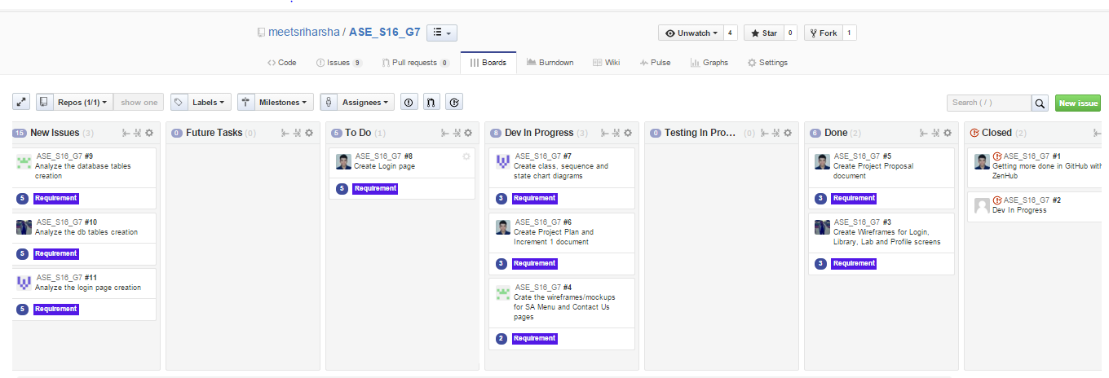

**Fig: ZenHub Board showing the project plan and current tasks.**

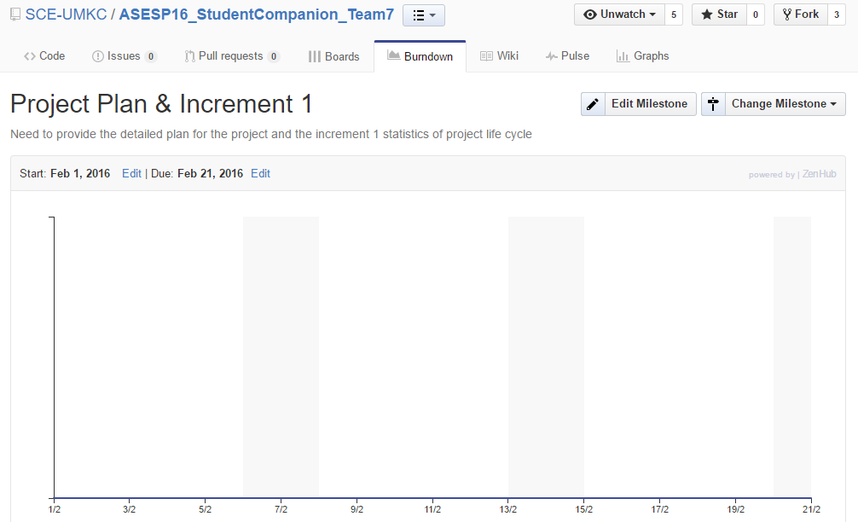

**Fig: Burndown chart for Milestone 1**

# Milestone 2

**Duration:**

Start: February 22, 2016

End: March 11, 2016

Days: 19

**Task done:**

This milestone mainly deals with the designing the system for the implementation phase. The tasks of this phase mainly focuses three tasks.

First, the development of basic skeleton which gives pleasant UI to the user.

Second, development of login page and authentication of user using his/her credentials which are stored in the mongoDB.

Third, creation of database using mongoDB , populating the database and accessing the database using monoDB API.

**Task Responsibility:**

Development of basic skeleton is done by Raj Kiran Reddy and Suhas.

Second, development of login page and authentication of user using his/her credentials which are stored in the mongoDB.

Database part is done by Sri Harsha.

**Issues:**

Issues are regarding database access whether to use an API or to use driver to access data from the mongoLab and this issue is resolved in milestone 3.

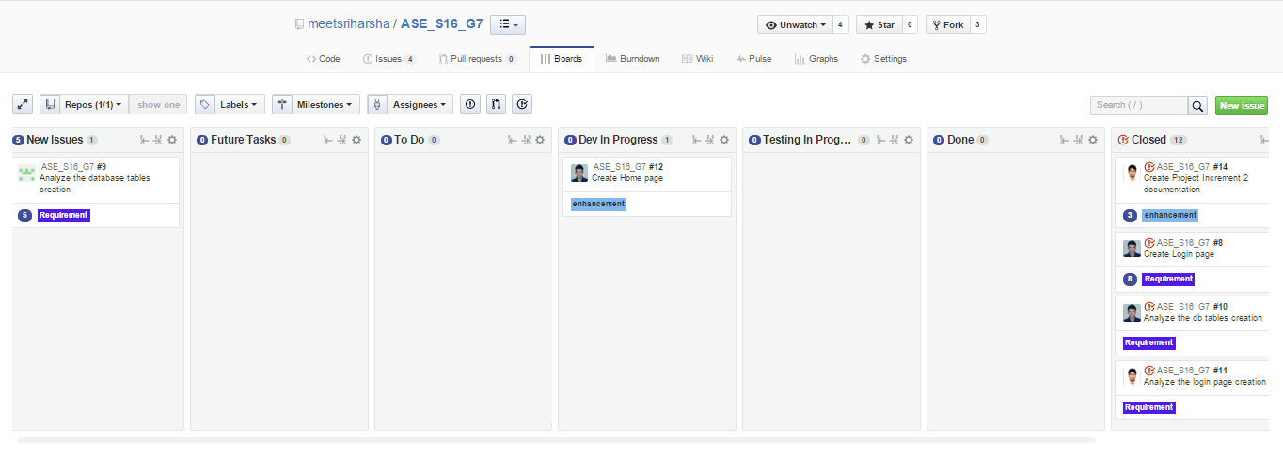

**Fig. ZenHub Board showing the project plan and current tasks**

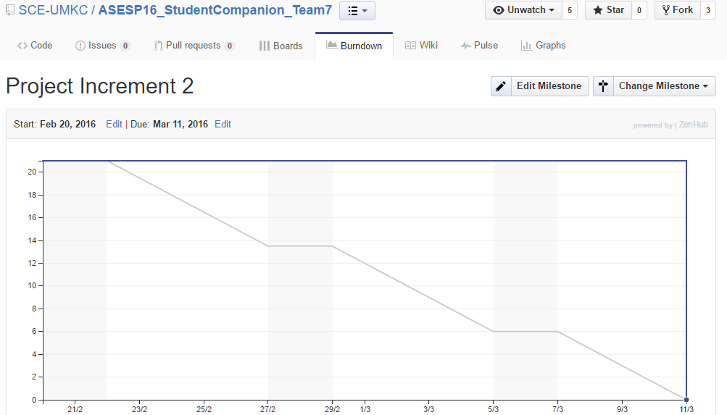

**Fig: Burndown chart for Milestone 2**

# Milestone 3

**Duration:**

Start: March 12, 2016

End: April 6, 2016

Days: 26

**Tasks Done:**

This milestone mainly deals with the designing the end to end functionality of the system. The tasks of this phase mainly focuses six tasks.

First, the development of REST API which performs the communication between Client application and database.

Second, development of View profile page and displaying the profile of the user which is stored in the mongoDB, registration page and its functionality and contact us page with contact information related to IS call center.

Third, development of Lab Information page and display the Lab name, available work stations and systems which are in use in that lab.

Fourth, development of Reserve Study Room page and display the Library information, study rooms which are reserved by the user and available study rooms.

Fifth, development SA Menu page and display the SA Shifts of the user on a or after a particular date.

**Tasks Responsibility:**

First and fourth tasks are done by Sri Harsha.

Second task is done by Teja.

Third task is done by Suhas.

Fourth task is postponed to the next increment as it has some complex logic to implement.

Fifth task is partially done by Raj Kiran Reddy and remaining work is continued to the next increment.

**Issues:**

Issues are regarding static database and it is ignored and continued forward. Implementation of REST API and deploying it in the Amazon Web Services has taken long time as each and every line of the code has to be tested in incremental state.



**Fig: ZenHub Board showing the project plan and current tasks**

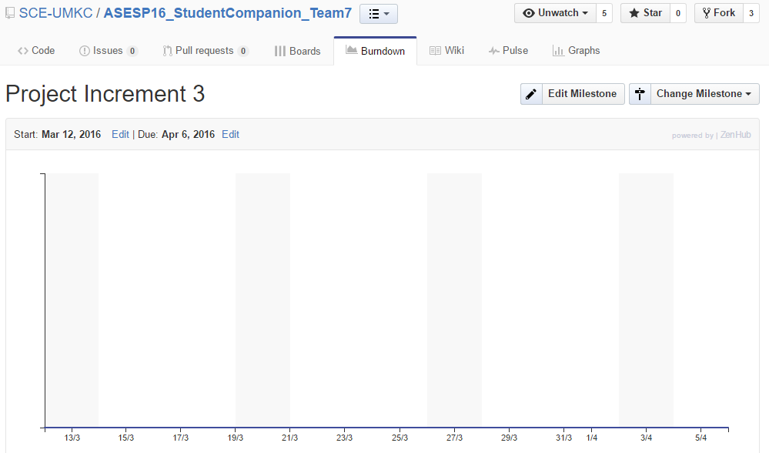

**Fig: Burndown chart for Milestone 3**

# Milestone 4

**Duration:**

Start: April 7, 2016

End: April 29, 2016

Days: 23

**Tasks Done:**

This milestone mainly deals with the designing the end to end functionality of the system. The tasks of this phase mainly focuses six tasks.

First, the development of REST API which performs the communication between Client application and database.

Second, development of View profile page and display the profile of the user which is stored in the mongoDB. Developed the full functionality for registering user and added validations to registration page. Developed editing profile page and editing password of user with complete logic.

Third, development of Lab Information page and display the Lab name and lab details.

Fourth, development of Reserve Study Room page and display the Library information, study rooms which are reserved by the user and available study rooms and the details of resources present in it and cancellation of reserved study room.

Fifth, development SA Menu page and display the SA Shifts of the user and available shifts on a selected date. Developed the functionality for taking the available substitutions.

Sixth. Implemented the toast functionality for the final application.

**Task Responsibility:**

First and Fourth task is done by Sri Harsha.

Second task is done by Teja.

Third task is done by Suhas.

Fifth task is done by Raj Kiran Reddy.

Sixth task is done by Sri Harsha and Teja.

**Issues:**

Sometimes we are getting black background while navigating to login page from registration page due to some unknown bug in ionic framework, this is happening only in browser whereas in mobile it’s working fine. Sometimes we are getting asynchronous results from API in Home page.

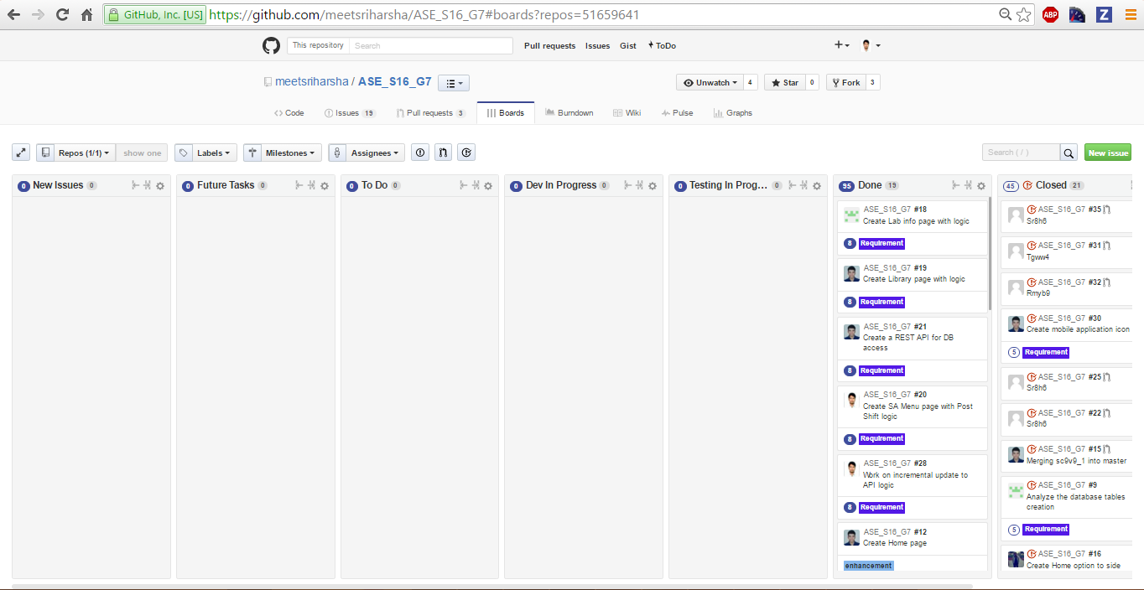

**Fig: ZenHub Board showing the project plan and current tasks.**

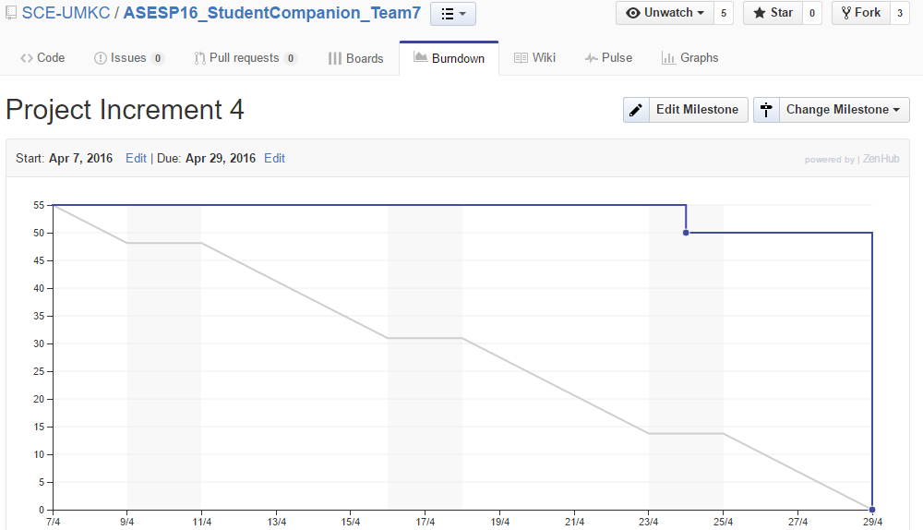

**Fig : Burndown chart for Increment 4**

**Agile website link:**

[https://github.com/SCE-UMKC/ASESP16_StudentCompanion_Team7#boards?repos=51659641](https://github.com/SCE-UMKC/ASESP16_StudentCompanion_Team7%23boards?repos=51659641)

**Source Code GitHub URL:** <https://github.com/SCE-UMKC/ASESP16_StudentCompanion_Team7>

**Presentation URL:** <https://github.com/SCE-UMKC/ASESP16_StudentCompanion_Team7/blob/master/Documentation/StudentCompanionBriefPPT_Group_7.pptx>

**YouTube Application Demo Video URL:** <https://www.youtube.com/watch?v=v6NcbSS8hcQ>

# Final Project Evaluation:

We’ve taken all the precautions to make sure that our project satisfies every possible outcome of the original requirement specifications. We’ve analyzed various application user interface patterns before we commit to the current one. We considered several factors such as application run environment, end users etc., to decide the application design pattern. Agile process helped us in exchanging the information, knowledge and project status updates effectively and immediately. We inherited several aspects of agile methodology in our project management processes. One of them is weekly team meetings on project status, issues and future work. This helped us in quick decision taking for the tasks.

I’ve faced some difficulty in my team as some team members are not completely familiar with the Ionic framework concepts. To overcome this, we’ve planned our work ahead of our task deadlines and were successful in completing them. We’ve also faced the “Billing” problem from Amazon Web Services as the “free” tier services are not really free. There are some limitations on the free tier like “one month free” or “2 million request hits free” etc., It should have been highlighted earlier in our tutorial classes.

If this was a real world project, I would have arranged internal team meetings every week. Also, I will arrange meetings with the clients to explain the tasks done till date and to take input suggestions from them. As the semester course was started with android basics and the important technical content (ionic framework, angularJS) was started at the end of the semester, our first two increments really don’t have much progress. This could be resolved by changing the course work flow. Other than that, all the remaining course and project schedules were perfect.